Design:

\*Main tabs of the overall project are on top and subtabs can be found on the side.

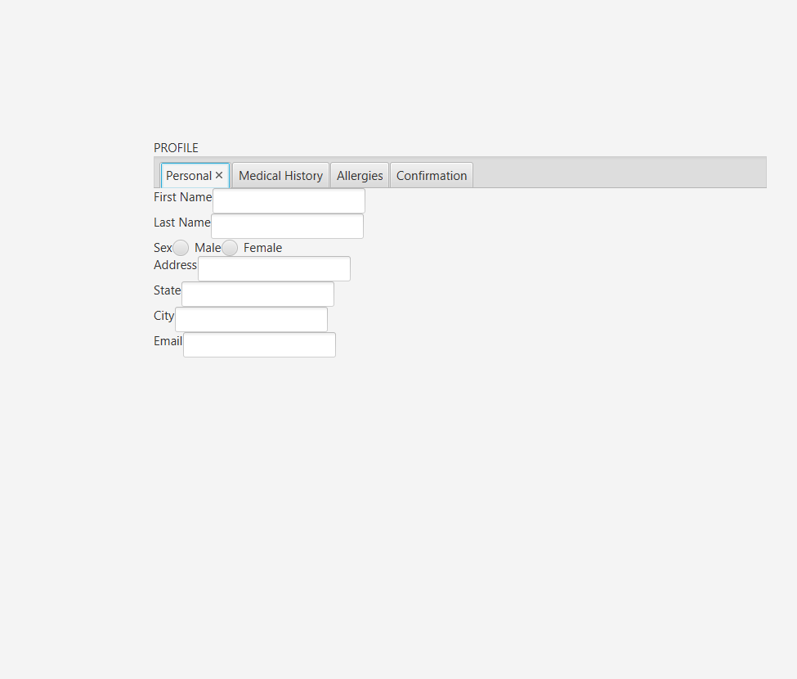

The tab for profile and the rest of the tabs for the overall project would be on top and Personal, Medical History, Allergies, and Confirmation can go on the side, like in the image below.

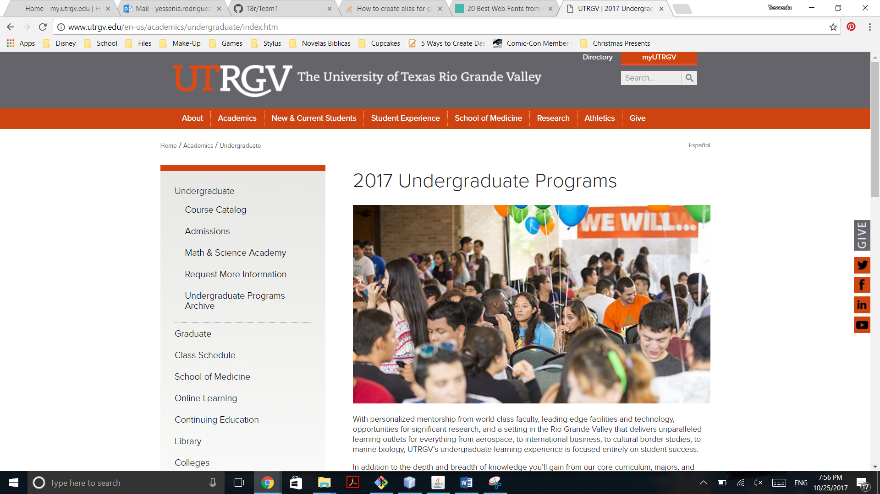

\*UTRGV Themed

* Colors:

A screenshot of a social media post

Description generated with very high confidence

* Logo:

A screenshot of a cell phone

Description generated with very high confidenceA screenshot of a computer screen

Description generated with very high confidence

Font:

Verdana (size: 25, FontWeight.Medium)